Science pack
Year 5 & 6

Contents
PEPPERED MOTH AND CAMOUFLAGE
Images of the peppered moth
Info and Questions on the peppered moth
Spot the moth
Peppered moth story and activity

World of Survival: Zwimble world of survival of an imaginary animal in an imaginary environment
Design your imaginary Zwimble dog
The story of Zwimble world

EVOLUTION
What is evolution?
Activity: Design a new feature you’d like humans to evolve to help us survive

ULTIMATE ANIMAL
Create your own ultimate animal for survival

WORLD ANIMALS
Mindful colouring sheets whilst learning about the world animals

SPACE EXPLORATION 2020
Information of Space Exploration in 2020
Create the space model
Design your own space hotel and space transport

Dark coloured peppered moth
Pale coloured, speckled peppered moth

Pale and dark coloured peppered moths on silver birch tree trunk

The Peppered Moth
Peppered moths rest on silver birch tree trunks with their wings outstretched, this behaviour can make them easy prey for birds. Originally the peppered moth was only recorded in the paler speckled form, but during the industrial revolution in the UK (about 200 years ago) dark coloured peppered moths started to be recorded.

Whilst the numbers of the dark form of the peppered moth increased dramatically, the paler speckled form became scarce in some areas. However, in more recent times the numbers of the dark form have declined relative to the pale form.

www.arkive.org/peppered-moth
Watch the videos and read the information about the peppered moth and answer:
- Why was the original form of the peppered moth pale and speckled? What advantages did this bring to the species whilst resting on tree trunks?
- What happened during the industrial revolution which allowed the dark moths to evolve and increase in numbers? What advantages did the darker moths now have?
- What happened in 1964 which resulted in the decline in the darker form of the peppered moth?
- What types of factors have influenced the evolution of the peppered moth in the last 200 years? Why was the evolution of this species so fast?

The peppered moth is a ‘model’ for natural selection. The use of models is important in modern scientific investigation, they help scientists to investigate their theories and prove whether they are right or wrong. In the case of the peppered moth, their evolution by natural selection has helped scientists to prove Darwin’s original theory.

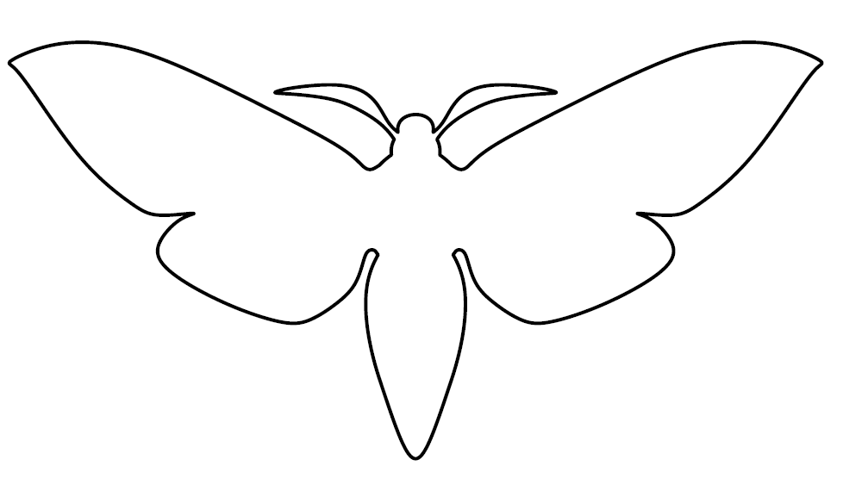
Animals Including Humans – camouflage
Activity 1: SPOT THE MOTH
- Choose a surface such as a wall, a tree trunk, a fence or any other vertical surface.
- Using the template below, design a moth which will be camouflaged against this surface. Use paints, crayons or felt tips to create suitable colouring and patterns OR use things in the environment to decorate it.
- Attach the completed moth to the surface.
- Stand as far away from the surface as possible, and then walk closer and closer until you spot the moth. Measure the distance to the moth when you spot it.
- Repeat with other moths.
- The moth with the shortest distance is most likely to survive, as a predator has to be really close up before it is spotted. Look carefully at the camouflage. Why was it successful and how does it compare to real moths?

Adaptation and Evolution

Activity 1 – The peppered moth story

You will need:
  - 2 pieces of white or light paper
  - 2 pieces of black or dark paper
  - Scissors

Keep one sheet each of the light and dark paper as background.
Cut 6-8 small triangles (pretend moths) from the light and dark paper.
First place lots of light triangles (moths) and a few dark moths on the light background.
Imagine you are a bird picking off the ones which are most easy to see. Mostly light moths remain. Add a few extra light moths as these are most likely to survive and reproduce, making more light peppered moths.
Add some extra light moths.
The Industrial revolution caused pollution to increase and trees to blacken.
Now try the same on the dark background (a few dark moths and lots of light moths).
Imagine you are a bird picking off the ones which are most easy to see. Now mostly dark moths remain. Add a few extra dark moths as these are most likely to survive and reproduce, making more dark peppered moths.
The air was gradually cleaned up and trees lightened again. Go back to the light background and move the moths across.
Imagine you are a bird picking off the ones which are most easy to see. Now mostly light moths remain again. Add a few extra light moths as these are most likely to survive and reproduce, making more light peppered moths.

Which peppered moths are better adapted to the current tree colour?

Zwimble World Survival of an imaginary animal in an imaginary environment

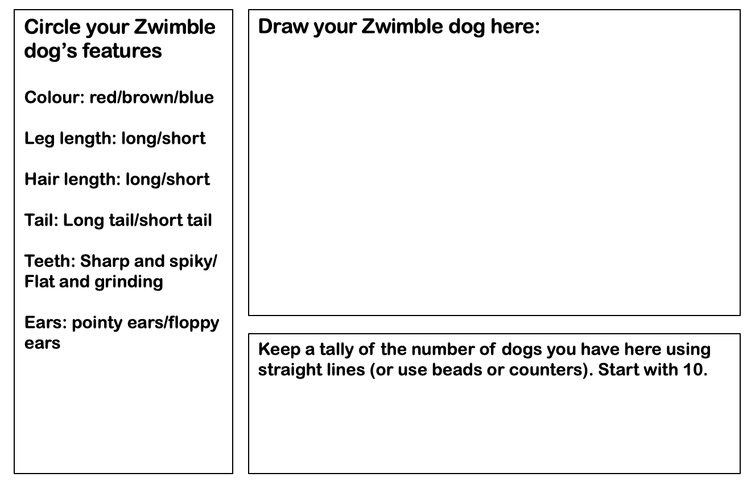
Choose the features from the list on the left for your imaginary Zwinble dog in Zwimble land, draw a picture and then keep count of how many Zwimble dogs you have at the end of the activity.

The story of Zwimble World
Welcome to the land of Zwimble dogs.
Tall Zwimble dogs, short Zwimble dogs. Zwimble dogs with long legs and spiky teeth. Zwimble dogs with floppy ears and some with big, sharp claws. A huge variety of Zwimble dogs all living in their Zwimble dog land.
Make sure that you now have ten Zwimble dogs tallied onto your page. We are going to follow the story of your Zwimble dog.
1st generation Zwimble dogs: It’s the height of summer, the hottest summer that has ever been and temperatures soar at 38 degrees. Zwimble dogs with long hair suffer from dehydration. Short haired Zwimble dogs, however, roam around freely and don’t get too hot.
If your Zwimble dog has long hair they can’t keep cool and some die without having babies; lose 3 Zwimble dogs. If your Zwimble dog has short hair it is more likely to survive and reproduce; gain an extra 3 Zwimble dogs.
2nd generation: The offspring of your first Zwimble dogs roam the land and food is plentiful. The Zwimble dogs are happy. However, forest fires spring up, ravaging the land and consuming everything in their wake. Long legged Zwimble dogs are able to run quickly and are better able to out-run the spreading fires. Short legged Zwimble dogs, sadly, are more likely to be consumed by the flames.
Long-legged Zwimble dogs are more likely to survive and reproduce; gain 4 Zwimble dogs. Short-legged Zwimble dogs sadly lose out – lose 3 stickies.
3rd generation: The great grand-dogs of your first Zwimble dogs are now in charge. It’s springtime and blood-sucking ear mites are in breeding season. Zwimble dogs with long tails can swish away the flying monsters although having pointy ears are makes some Zwimble dogs an easy target.
If your Zwimble dog has a long tail it is more likely to reproduce than those with a short tail. Long tailed Zwimble dogs, gain 5 dogs, short tailed Zwimble dogs lose three. If your Zwimble dog has pointy ears, halve in number, if your Zwimble dog has floppy ears, add five.
4th generation: The great great grand-dogs of your first Zwimble dogs pound along. It’s been a tough year and the normal food source of the Zwimble dog (Zwimble zebra) are few and far between and Zwimble dogs have had to look for new things to eat. Luckily, Zwimble Dog Land also has a large number of Zwimble-trees which grow Zwimble nuts. Not quite as tasty as the zebra but very nutritious.
Zwimble dogs with flat grinding teeth are able to grind away at the hard shells of the Zwimble nut to get to the nutty prize. Zwimble dogs with sharp pointing teeth aren’t so lucky so many go hungry and die. If your Zwimble dogs have sharp teeth, lose 4 Zwimble dogs. If your Zwimble dogs have grinding teeth gain an extra 10.
5th generation and our story is coming to an end: Shhhhh! A new predator is on the loose and it finds Zwimble dogs very tasty. Long legs won’t help, nor will good hearing. The only thing that might save you is camouflage. Red Zwimble dogs blend in a little with the red flowers on the top of the Zwimble-trees. Brown Zwimble dogs are the masters of disguise and look just like the tree trunks of all the vegetation found in Zwimble-dog land. Blue Zwimble dogs, you stick out like a sore thumb and will make a very tasty meal. Red Zwimble dogs, gain 5, blue Zwimble dogs lose 5, brown Zwimble dogs add 10.
Now count up the number of Zwimble dog you have at the end of 5 generations.

What is evolution? Evolution is a gradual change in living things.

Babies are not usually exact copies of their parents. Some of their features are slightly different. For example, a baby monkey might grow up to have longer arms than its parents, so it would be better at climbing trees. study

Why evolve? Changes to habitats often trigger evolution.
Millions of years ago, our ancestors -apes-lived in forest. Then the forests died and were replaced by grassland. The apes who could run fastest survived, not the ones who climbed tress best.

EVOLUTION-OVER TO YOU!

Imagine you could control evolution. Design a new feature you’d like humans to evolve to help us survive more easily

The new feature I would like humans to evolve is….

This feature would make it easier to survive because….

Here is a picture of a human with this new feature

ULTIMATE ANIMAL

Can you create your ultimate animal?
What is its habitat like?
What would you like it to do?
What will it eat?
Why has it got certain features of animals?
Has it got any predators?
Does it Prey on anything?

Mindful Colouring of World Animals

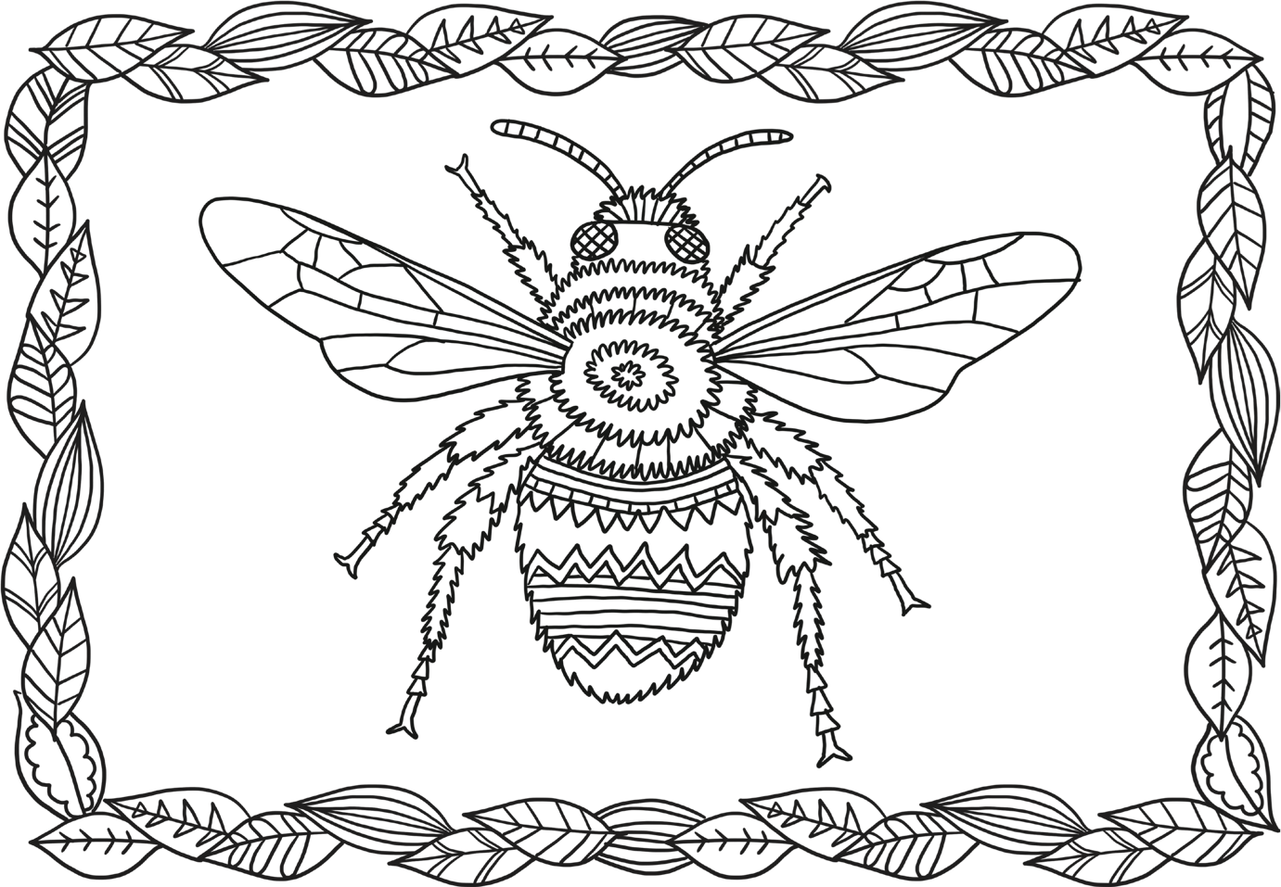

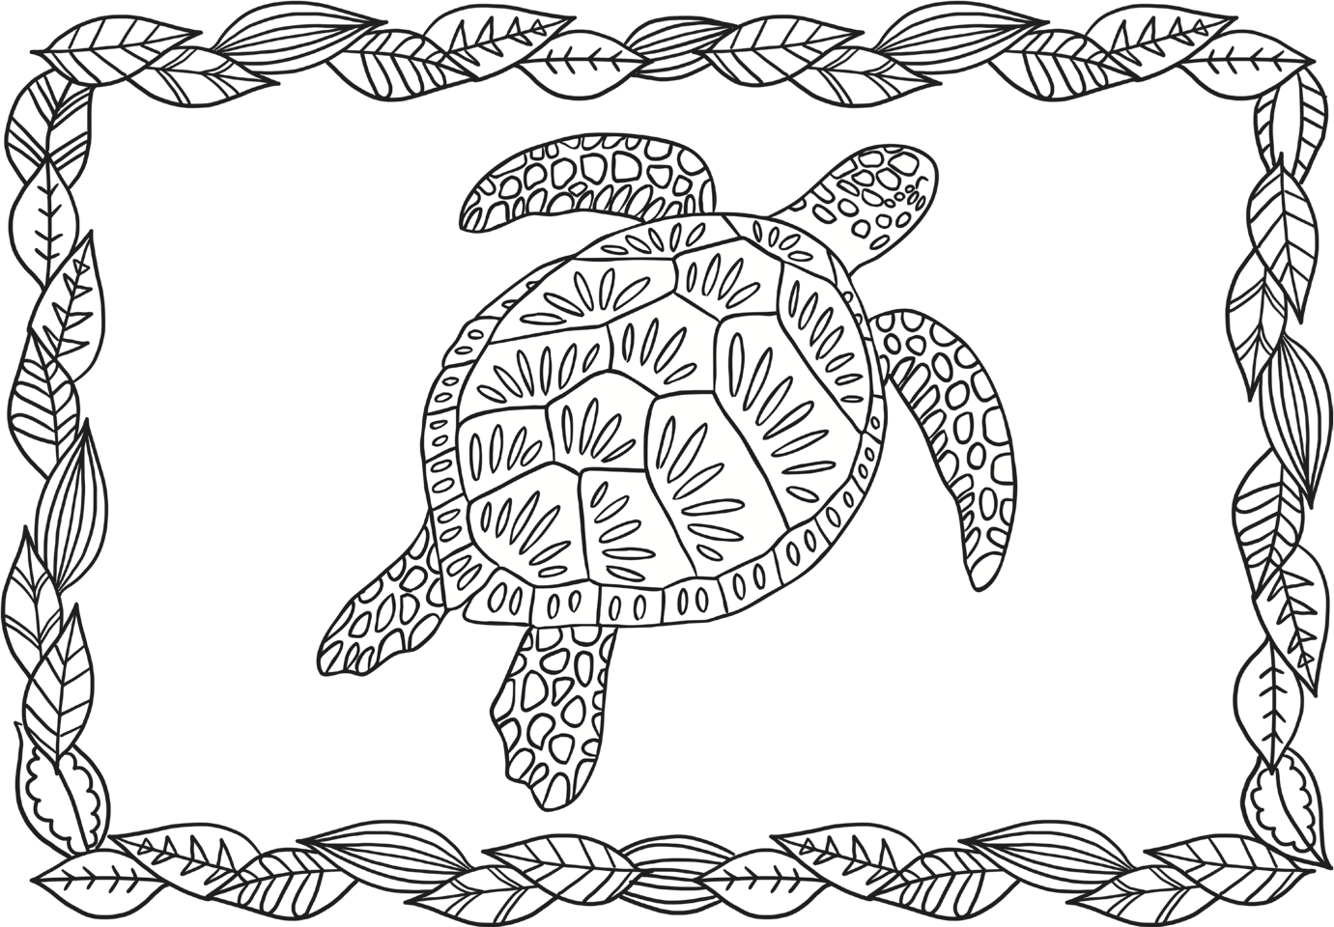

Space launch calendar 2020

SpaceX Crew Dragon

What is the SpaceX Crew Dragon? Commercial space companies and national bodies are working closer together in an effort to reduce the costs of space travel. SpaceX’s Crew Dragon is just one example.

Since the Space Shuttle was retired in 2011, the only way that astronauts have been able to travel to and from the International Space Station (ISS) has been via Russian Soyuz spacecraft. NASA has therefore commissioned private companies SpaceX and Boeing to deliver new spacecraft designed to ferry astronauts to the ISS and back.

In March 2019 the SpaceX-designed ‘Crew Dragon’ became the first privately owned spacecraft to successfully dock with the ISS. In 2020 it will return - this time with astronauts on board.

NASA is planning to send two of its astronauts to the ISS aboard the Crew Dragon, in what will be SpaceX's first ever crewed mission to space. The launch was initially set to take place on Wednesday 27 May, but bad weather forced NASA to cancel with only 20 minutes to go. The launch is now scheduled for Saturday 30 May at 8.22pm UK time (3.22pm EDT).
The three-week-long Artemis 1 spaceflight aims to travel 280,000 miles from the Earth and thousands of miles beyond the Moon before returning home. Crewed Artemis missions will follow, culminating in humans returning to the Moon’s surface by 2024.
Artemis 1
What is the NASA Artemis Program? NASA aims to land the first woman on the Moon and the next man on the Moon by 2024. This mission is known as the Artemis Program (Artemis was the twin sister of Apollo in Greek mythology).

The timeframe is ambitious, and there will be a number of stages before that final mission in 2024. Artemis 1 is the first milestone: the mission is designed to test the crew spacecraft Orion and NASA’s new Space Launch System (SLS), the most powerful rocket NASA has ever built.
NASA had been aiming for a launch date in late 2020 for Artemis 1. However, Administrator Jim Bridenstine suggested in December 2019 that the launch might not take place until 2021.

NASA Mars 2020 Rover
What is Mars 2020? This is NASA’s latest mission to explore Mars, and one of four potential journeys to the Red Planet in summer 2020. The new NASA Mars rover will search for signs of life, collect rock samples, and test a new technique for producing oxygen from the Martian atmosphere which could pave the way for future human missions to Mars. This experiment is called the Mars Oxygen In-Situ Resource Utilization Experiment, or MOXIE for short.
The rover features a number of new scientific instruments, including a drilling tool designed to extract and ‘cache’ rock samples that could be brought back to Earth by future missions. It also includes a tiny ‘helicopter’, designed to explore Mars from the skies.
NASA Mars 2020 launch dates: 17 July-5 August 2020
Landing date: 18 February 2021

ExoMars 2020 - DELAYED
What is ExoMars 2020? The favourable alignment of Mars and Earth initially made 2020 a major year for Mars exploration. As well as the NASA Mars mission, the European Space Agency (ESA) planned to send its own rover - Europe’s first - to the planet. The rover is called Rosalind Franklin after the British DNA pioneer, and is designed to extract and analyse rock samples and search for traces of life on Mars.
The project however will now be delayed until the next favourable launch window in late 2022, after the agency decided that there was not enough time to run essential tests prior to launch.
“We want to make ourselves 100 per cent sure of a successful mission, said European Space Agency director-general Jan Woerner. "We cannot allow ourselves any margin of error. More verification activities will ensure a safe trip and the best scientific results on Mars.”
ExoMars 2020 launch dates: tbc
Landing date: tbc

China Mars probe and Hope Mars mission
Two further Mars missions are planned for 2020. China aims to launch what would become the country’s first successful Mars mission, with the project combining a Martian orbiter and a planetary rover in one.
The Hope Mars mission meanwhile is an orbiter project run by the United Arab Emirates, and is set to be the nation’s first mission beyond Earth’s orbit.
Launch dates: July-August 2020

Starlink - SpaceX
What is Starlink? Commercial space company SpaceX plans to launch a pioneering new satellite system, with the aim of providing global high speed internet connection from space.
According to the plan, thousands of communication satellites will be launched in the 2020s. The first 60 satellites launched in May 2019, but the company has permission to launch a total of at least 12,000 in order to build its global network.
The project has been criticised by some astronomers worried about the satellites’ impact on night sky observation, while others have highlighted the increased risk of mid-orbit collisions.
In October 2019, SpaceX founder Elon Musk claimed he had successfully sent the first tweet via Starlink satellite broadband.

Solar Orbiter
What is Solar Orbiter? The European Space Agency and NASA's new probe is designed to study our Sun close up. Launching in 2020, the mission will help us analyse the ‘heliosphere’, the vast bubble of charged particles that surrounds the whole Solar System, and examine the Sun in greater detail than ever before. The seven-year mission will perform numerous fly-bys of both the Earth and Mercury before it reaches its eventual destination.
Solar Orbiter launch date: 10 February 2020 at 4.03am GMT (date subject to change)

Chang’e 5
What is Chang’e 5? The China National Space Administration (CNSA) is planning to launch a mission to the Moon, reportedly in late 2020. The mission will consist of both a lunar rover and a system designed to land on the Moon, collect samples, take off again and return the samples to Earth.
If successful, China will become only the third country in the world to collect lunar samples after the USA and the Soviet Union. China’s previous mission Chang’e 4 landed a lunar rover on the far side of the Moon in January 2019.
Chang’e 5 launch date: late 2020 (TBC)

Boeing CST-100 Starliner
What is Starliner? SpaceX is not the only company working to transport astronauts to the ISS. Boeing’s spacecraft, known as CST-100 Starliner, is also designed to carry both crew and cargo to the space station. Both companies are aiming to be the first to send astronauts into space from American soil since 2011. However, like SpaceX, Starliner has faced launch delays.
In December 2019, Starliner was meant to complete a full uncrewed test flight to the ISS and back. However, an issue with the craft's onboard timing system meant that the capsule found itself in the wrong orbit, and could not complete its docking with the space station.
The capsule did later successfully return to Earth and land safely in New Mexico, but it is unclear whether Boeing will have to complete another uncrewed test before astronauts are able to travel to the ISS in Starliner.
The Boeing CST-100 Starliner spacecraft landed in White Sands, New Mexico after it failed to reach the International Space Station (NASA)
Boeing CST-100 Starliner launch dates: 2020 (TBC following unsuccessful uncrewed test in December 2019)

TASK 1 Draw your exterior and interior design labelling important features

TASK 2: Design a space hotel

