Speaking and listening
- Can you describe what it feels like to be caught in a storm?
- What do you think the men heard when they listened to the storm?
- Who might the men in the lighthouse be?
- Why are they huddled together?
- What is the purpose of a lighthouse?
- What would happen if there were no lighthouses in the world?
- How do you think someone first invented lighthouses?
- Can you think of an alternative way to guide ships?
- Do modern lighthouses require people to work inside them?

Sentence Challenge
What does ‘their hearts were in their mouths’ mean?
Can you write a description of how it feels to be caught in a storm? Try to think about what other things might happen to your body when you’re afraid. E.g. what happens to your heart? What happens to your skin?

Continue the story
The storm had been raging for hours. Like a besieging army tormenting an enemy’s ramparts, the waves battered on the lighthouse walls.
A group of men huddled in one of the cylindrical shaped rooms, flinching every time a wave rocked the lighthouse. Their hearts were in their mouths with every devastating blow: they half expected the walls to come tumbling down at any moment.
They turned their heads and listened to the sound of the storm. What they heard was truly terrifying…

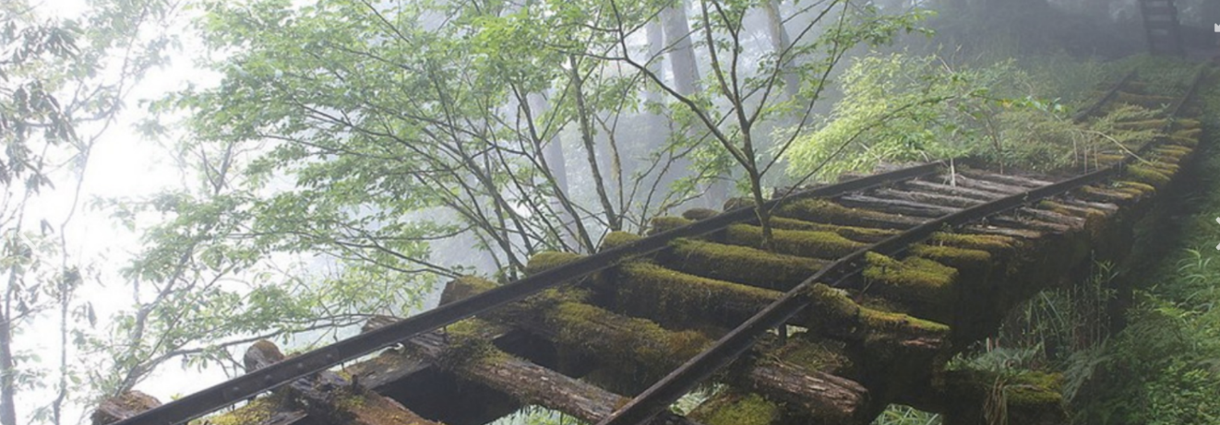
Speaking and listening
- What might have happened on June 11th, 1911?
- What stories have their fathers told them?
- Who is sitting around the campfire?
- Why are they out in the woods?
- What is the noise that they have heard?
- Was it part of their imaginations, or something more sinister?

Improve the sentences
They sat in the woods. They lit a fire. They built a camp. They told stories. Then they heard a strange noise.

Draw a picture
Can you draw a picture of what might have made the shrill, shrieking noise in the distance?

Speaking and listening
- Why is Elsa in The Great House?
- Why are some rooms ‘out of bounds’ to her?
- What time of day do you think it is?
- How does Elsa feel as she enters the library?
- What is she hoping will happen in the library?
- What happened the last time she was here?
- Will anyone notice she has gone?

Sentence Challenge
Can you identify all the verbs I have used below? Can you replace them with more interesting verbs?

Elsa walked bravely across the floor. Light came down from the windows. She looked back over her shoulder to see if anyone was there.

Continue the story
The Great House had many hidden treasures. As a 10 year old girl, many of the rooms were out of bounds for Elsa, but her desire for adventure often got the better of her…
She peeked back over her shoulder to check that the coast was clear. She could hear one of the butlers clattering around in the kitchens at the far end of the hall; no one knew she was there.
She carefully turned the ornate, golden door handle, hearing the mechanism inside clunk, and eased the heavy, wooden door open just enough to slip inside the room.
Immediately, Elsa was bathed in light as it poured down from the circular windows in the ceiling. She could see dust dancing in the beams of sunlight.
With a flutter of excitement inside her chest, she strode confidently into the centre of the room, her shoes click-clacking off the chessboard-like floor. She loved this library – it felt like she was ‘in’ history. How many lords and ladies had graced this great room? It has stood here for centuries, and Elsa doubted that little, if anything, had changed over the years.
Elsa loved reading, but that wasn’t why she had come to the library. She approached one of the golden orbs lined up along the centre of the library floor, and carefully placed her finger on the top. It had worked last time. Would it work again? She longed for the magic to happen, and closed her eyes in silent prayer…

